TOP SURGERY

CHEST REDUCTION & RECONSTRUCTION

Medical Providers

Primary Care Providers and Gender Affirming Hormone Therapy Providers
Our Primary Care Physicians (PCP) or Gender Affirming Hormone Therapy (GAHT) Providers help us plan safe and affirming procedures.
Primary medical providers help us figure out if we are physicallyhealthy enough to have surgery and recover after.
These providers can also help us prepare, process and advocate for our needs throughout the surgery navigation process.
Once we have decided we are ready for top surgery, our medical provider will update our medical history and routine or prevention health exams.
Any health conditions we have should be well controlled and stabilized when we are recommended for surgery. This means that we are not having any flares, episodes or events that are not expected or able to be addressed.
A specialist (such as a cardiologist) may need to review our medical history or results from exams before we can be cleared to have surgery. This helps providers take a closer look at what our body needs for a safe surgery and recovery.
My Primary Care Provider is:
- Office Name:
- Phone Number:
My physical health conditions:

My medications:

My other medical providers:
Provider Name:
- Office Name:
- Phone Number:
Provider Name:
- Office Name:
- Phone Number:
This is the ideal time to talk about ways to stop any smoking or vaping, using nicotine products (including gum, chews or patches), or substance use before surgery and through recovery.
It’s best to avoid these for 2-3 months before and after surgery.
Our providers can refer us to resources that specialize in supporting folks through these changes. Most insurances cover supportive pro- grams that help take these steps.
Surgeons have strict requirements to stop nicotine and substance use before surgery because of the complications in healing and bleeding that they cause.
This is especially true when nipple grafts are part of our surgery.
Blood and urine tests before surgery confirm that we have stopped soon enough to avoid these complications. Some of these tests take a week to show results, which can delay surgery even more if they need to be re-done.
Surgery may be postponed or cancelled if our test results show nicotine or substances in our blood and urine.
My expected surgery date:
My surgery clearance appointment date:
Date to start cutting down:
Date to completely stop use:

Consultation
Next, we review the steps and details of the procedure with our surgeon at our consultation.
This helps confirm what expectations can be met, and which ones may not work or may look different on our bodies.
Photos and drawings of the shapes or changes we are looking for can help confirm that we know what each other is talking about, and that we are talking about the same thing.
We should work with our surgeons to plan the surgery that best fits our goals and their best techniques.

Requirements
Some surgeons have specific requirements for surgery candidates to meet before scheduling surgery. These requirements can range from physical therapy to weight gain/loss or mammograms and CT scans.
Following surgeon recommendations, attending appointments, and taking our medications all show that we can reliably meet the requirements for the best results from surgery.
Our medical providers can support us meeting these requirements in healthy ways. Sometimes they may also advocate to surgeons or insurance if we have been denied surgery or are given unrealistic requirements to meet.
The letters of support our providers send to surgeons and insurance confirm we have met requirements for surgery and advocate for us to schedule a surgery date.
For the best results, our providers and surgeons collaborate and communicate through these letters.
Insurance companies and surgeons each have specific guidelines for the number of letters we need, the type of providers that can write them, and what needs to be included.
Usually, these letters follow WPATH standards of care, however we should always confirm this with our surgeon before meeting with providers that are writing our letters of support for surgery.

Consultation Information
Surgery technique decided:
Surgeon Name:
Office Name:
Address:
Phone Number:
Fax Number:
Tests/ scans/ exams needed:
Expected/scheduled surgery date:
Letters needed from:
- Medical Provider
- Therapist
- Psychiatrist

Expectations
EXPECTATIONS
Before being referred to a surgeon we can think about what we want and what we expect from surgery.
Everybody is different, as are the changes that we would like to see after surgery. So, let’s think about what we want.
Terms like “masculine” and “feminine” can mean different things based on the time and place.
Cultural differences in what “natural” means may also translate differently between us and our surgeons.
Using words like soften, round, square, cinch, tighten, contour, or flatten to describe the changes we would like to see after surgery can make our expectations clearer.
Here we’ll break down surgery expectations into three basic categories: aesthetics, sensation, and function.

Aesthetic Expectations
Aesthetic expectations can include hopes or fears that we have about scarring, symmetry, or pre- serving anything from the surgery site (such as tattoos or birthmarks).
They can also include different ways we expect to see ourselves after surgery. The shape of our body and how it may feel to wear certain clothes can also help clarify expectations.
We can describe the way our chest will look:
• in daily clothes
• in silhouette
• in something special
• in the mirror
• in tight clothes
• no shirt!
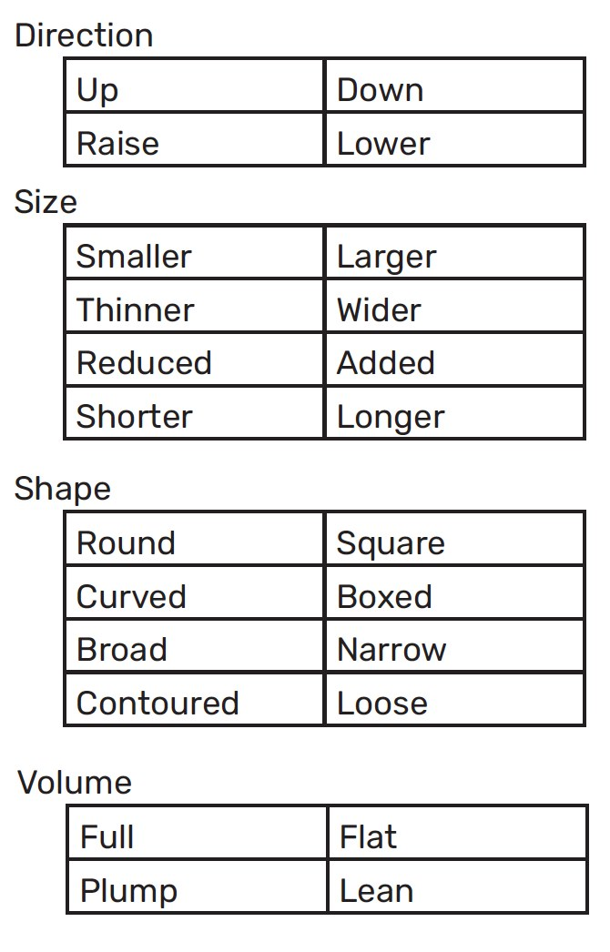
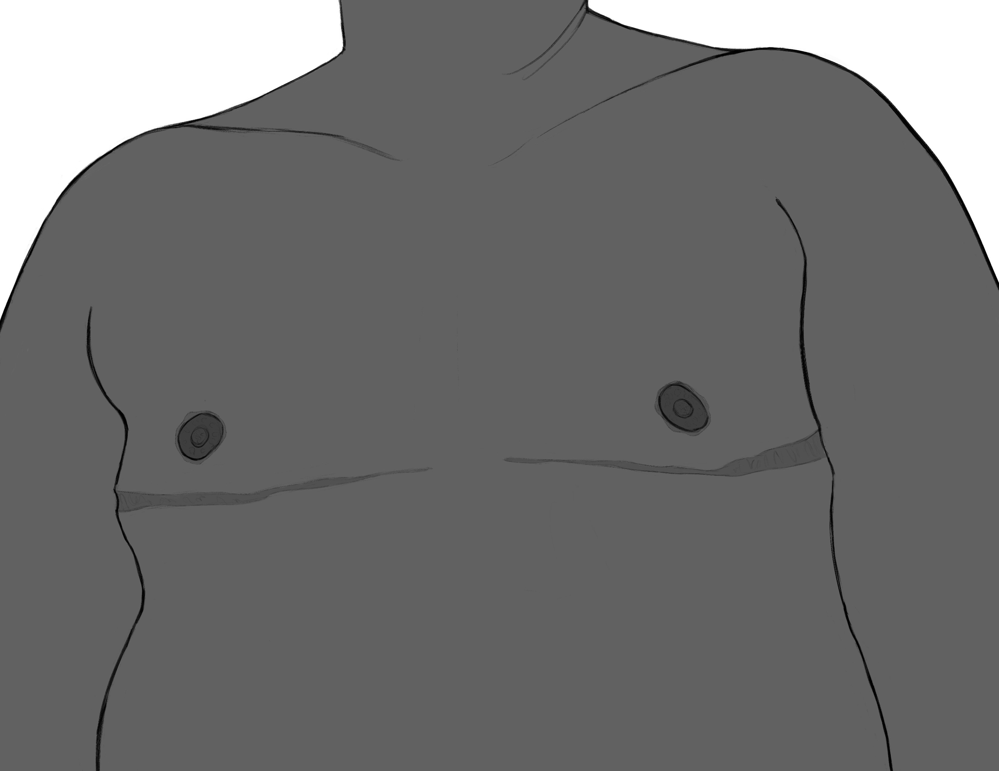

Reduction vs Reconstruction
Reduction and reconstruction surgeries look to remove tissue and skin to create a flatter chest.
Reduction surgery removes little to some of the tissue from the chest. Some skin may be removed to sup- port and contour the tissue that remains.
Reconstruction surgery will re- move some to most of the tissue from the chest. Skin on the chest is removed and contoured along our pec muscles.
There are different types of reduction and reconstruction procedures that we can choose from based on the amount of tissue we need to remove.

Reduction
Reduction procedures are ideal when we expect some of the tissue on our chest to remain after surgery.
Scarring can look different depending on the amount of tissue and skin that is removed. Depending on our surgeon, we may have options between inverted T scars, scars just under the chest tissue (along our pecs) or around the areola.
Our areola may be reduced in size to match the proportions of our chest. Depending on the amount of tissue removed and location of incisions, our nipple sensation may change or be slow to return after surgery.
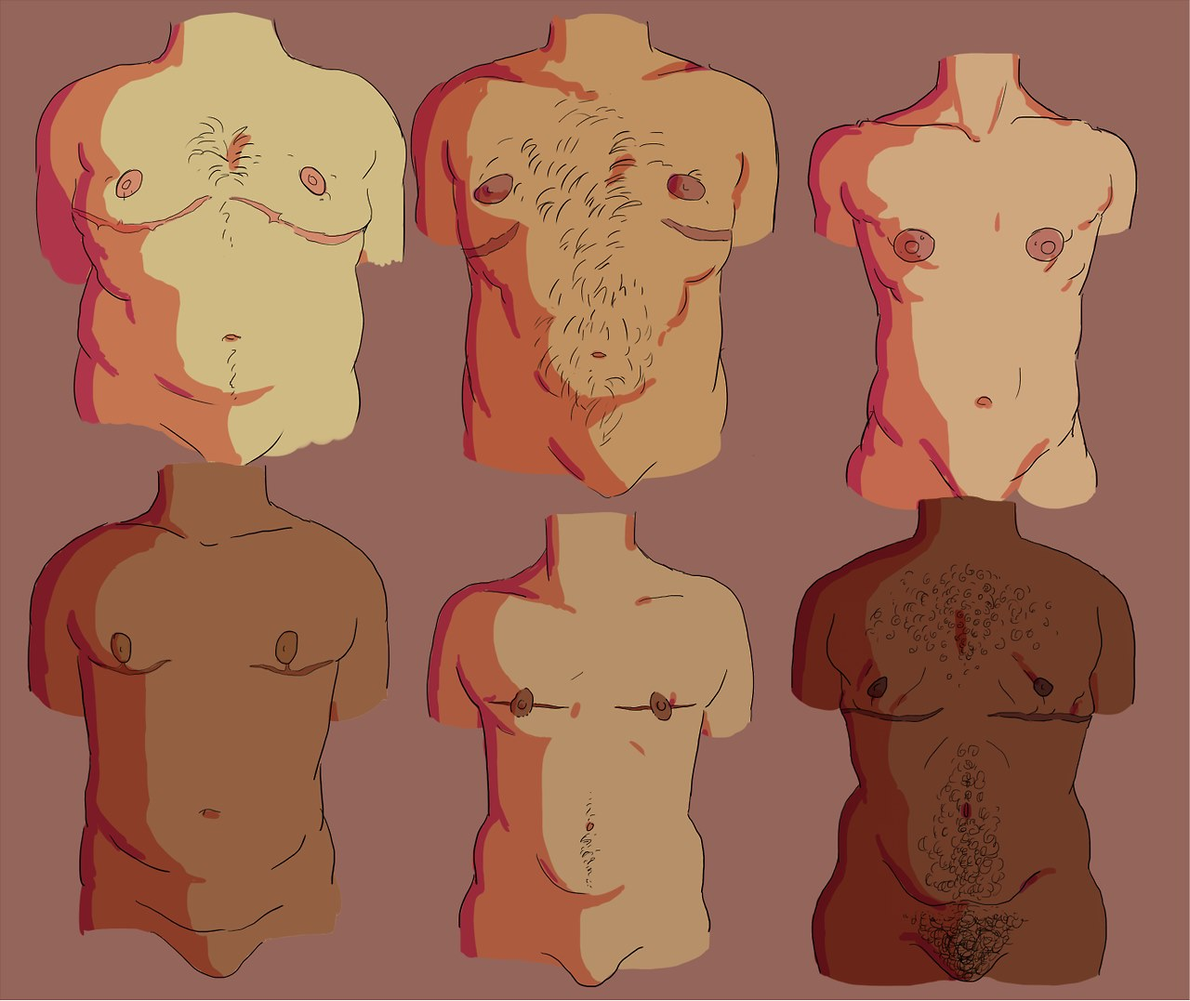

Reconstruction
Reconstruction procedures are ideal when we expect most of the tissue on our chest to be removed during surgery.
Scarring can look different depending on the technique we discuss with our surgeon. Depending on our surgeons’ experience we may have the option to choose between double incision, keyhole/ peri-areolar, fish mouth, and inverted T techniques.
Nipple grafts, or parts of our nipples and areolas, are removed then resized and placed back in a lower and outer facing direction. Before surgery the surgeon draws guides on our chest to be sure they line up as best as possible after recovery.

Sensation Expectations
Any surgery runs the risk of disrupting nerves in the area of the body where the surgery is being performed and may result in a change in sensation.
These changes are not just lack of feeling, but can also be:
- tingling
- painful
- sharp sensation
- hypersensitivity (sensation that is increased and bothersome)
- loss of specific elements of sensation like:
  - hot/cold
  - light surface touch
Small nerves that branch and supply feeling to the tissue will reconnect and regrow over years, but many factors such as age and other health conditions can affect healing time and nerve regeneration.

Sensation expectations can include hopes or fears we have about pain management, nerve damage or nipple sensation changes/loss.

They can also include different types of changes in sensation we may experience through recovery. Being specific about the type of sensation and time after surgery can help clarify expectations.
We can describe the way we ex- pect changes to our:
• touch and pressure sensation
• temperature sensation
• pain sensation
• erotic sensation
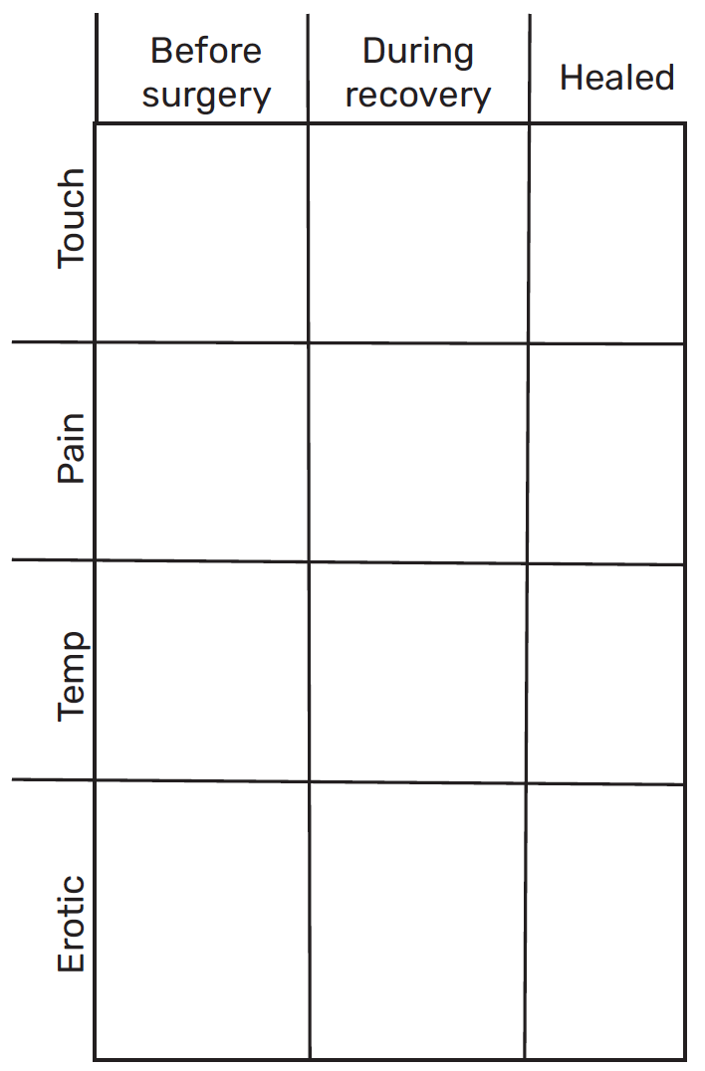

Common Surgeries

Peri-areolar
Keyhole surgery results include scarring along the bottom of our areola. Peri-areolar surgery results include scaring along our entire areola.
Small amounts of extra skin can be removed with either of these procedures.
Our chances of keeping our nipple sensation after surgery are higher because nipple grafts are not needed for these procedures.
Revisions to continue to remove additional tissue and skin may be needed later. It can take about one year to see the full results of this procedure.

Double Incision
Double-incision surgery results include scarring that runs across the chest. One or two scars are lined up with the bottom of our pec muscles. Scars may run further around our torso if we have been binding for some time and tissue has moved to the sides of our body.
A larger amount of skin is able to be removed with this procedure.
Nipple grafts are taken from the removed tissue and resized to be proportional for our chest. They are re-attached in a lower and out facing position. Most sensation is lost because of this step in the procedure but some may return over time.
Revisions for this procedure are less likely but may be needed to address dog ears over time.

Function Expectations
Function expectations can include hopes or fears we have about our activities of daily living, sexual function, or bowl and bladder function after surgery.
Our activities of daily living include things like
- Getting dressed
- Bathing or other self care
- Toileting
- Exercise or getting to our appointments
- Social interactions including safety in public spaces
Recovery is not linear, we may need different support over time.
It’s best to make plans for support with things like grocery shopping, laundry and taking care of other humans or pets for about a month to six weeks after surgery.
Function expectations can include hopes or fears we have about our activities of daily living, sexual function, or bowel and bladder function after surgery.
Our activities of daily living include things like
- Eating (sometimes support with preparing meals)
- Bathing (sometimes support with light cleaning)
- Dressing (sometimes support with light laundry)
- Toileting
- Transferring (moving from sitting or standing or from room to room)
- Caring for our incisions.
Recovery is not linear, we may need different support over time.
It’s best to make plans for support with things like grocery shopping, laundry and taking care of other humans or pets for about a month to six weeks after surgery.
My aftercare support person:
- Name:
- Relationship:
- Phone Number:
- Time at my side after surgery:
Backup support person:
- Name:
- Relationship:
- Phone Number:
- I need most help with:
Other hopes/fears/questions:

Time off from work/school/care for others:

General Expectations
How I describe my chest now:

Changes I want to see:

Hopes:
Fears:
Questions:

Aftercare

Recovery Space
The ideal recovery space after surgery is emotionally safe, clean for wound care, and stocked with essentials like food and toilet paper.
We should be able to get in and out of our bed or couch without using our arms. Recliners or wedge pillows may be more comfortable for a few days or weeks after surgery.
The adjustment to sleeping on our back through recovery may not be so intense if we are able to practice sleeping on our back before surgery. Pillows tucked in along our sides may help us stay in place while we sleep. An extra-long phone charger and bendy straws can ease the need to reach for or lift things.
Primary recovery space:
Back up recovery space:
Stairs or other things that make it hard to access my space:
Questions about preparing my bedroom or sleeping space:
Questions about preparing my kitchen or food preparation space:
Questions about preparing my bathroom or toileting/shower space:

Things to prepare
- The kitchen should be stocked with food for about one or two weeks of recovery.
- All appliances and utensils we use should be kept at waist level and within short reach.
- Carrying plates, bowls and cups may be hard for a few days after surgery and/or getting our drains pulled.
- Caregivers should help with meal prep and clean up for a few weeks.
- The bathroom should have things within short reach and at waist level for easiest use.
- Rather than bending forward, we can use a cup to raise water when we brush our teeth or wash our face.
- We may not be able to shower for several days after surgery. In the meantime, we can use items like bath wipes and dry shampoo to stay cool and fresh.

Transportation
Cars are ideal for our ride home and to follow up appointments in office.
Public transportation may be safe to arrive at surgery but will not be for riding after.
Pillows for our chest and neck on the way home can help us stay comfortable through our ride to our recovery space.

Drains & Compression
Depending on our surgeon, we may have drains placed in our chest and a compression vest to wear after surgery.
Although not every surgeon uses drains, it is standard to use a compression vest to limit swelling after surgery. The time we are in the compression vest depends on our surgeon, if we have drains, and our bodies’ reaction to surgery. We may need help getting the vest on or off for a few days after having surgery or our drains removed.
During surgery our drains may be placed at the edges of our incisions or a bit lower than the wounds on our chest.
Our surgeon will instruct us how to clean and strip the drains of any tissue before we are sent home to recover.
We will record the amount of fluid that is collected from each side for the surgeon every time we clean our drains.
They will use this as a gauge for our healing and to let them know when to remove the drains from our chest. Drains usually stay in for seven to ten days after surgery, or until we drain less than 30cc on each side. It’s normal to see some increase in swelling after our drains are removed.

Surgery Clearance
About a month before surgery, and once we have met all the surgeon’s requirements, we visit our medical providers for a Surgery Clearance visit.
It’s best to have this completed by our ongoing providers that are familiar with our overall health.
They will run blood work, urine tests and physically examine us for risk factors for surgery and recovery.
Any health records requested by the surgeon are completed during this appointment.

MENTAL HEALTH PROVIDERS AND EMOTIONAL SUPPORT THROUGH RECOVERY

Ongoing providers or support
Before surgery our therapist and/or psychiatrist will discuss our preparation for recovery, resources for support, and information about our mental health needs through surgery and recovery.
Generally, any mental health conditions should be well managed, and we should be working to plan for our emotional safety.
For some of us, this is the ideal time to talk about ways to stop smoking or vaping, using nicotine products, or substance use for surgery.
When possible, our ongoing therapist or psychiatrists should be our first choice for letters of support for surgery.
My mental health provider is:
Office Name:
Phone Number:
My emotional support person is: Name:
Relationship:
Phone Number:
My mental health conditions:
My medications:
We may feel triggered during conversations, exams, taking photos and reading letters with surgeons and other providers. Sometimes these things can trigger dysphoria that comes up for us later, after appointments with providers.

It’s important for us to discuss the things that keep us safe and affirmed throughout the surgery planning with our providers.

Our mental health providers can help us work on setting boundaries, staying grounded, and provide aftercare when we need it.

Build A Relax-Kit
- Think of your 5 senses: touch, smell, sight, hearing and taste.
- Gather favorite things for any or all of these senses as you are able.
- Collect them in a bag, box or area that is easily accessible after surgery.
- Work these items into your aftercare plan or keep it around to use as needed.
Try and use these items when caring for yourself or if know that things may get overwhelming.
Some of your favorite frozen fruit in a water bottle can help stay hydrated, or favorite scents while completing wound care can help us stay grounded.

Post- Op Depression
Many of us experience feelings of depression after surgery. This can come on a few hours, days or weeks after surgery and last just as long.
These feelings are not a reflection of how much we wanted or were ready to have surgery. They are a normal part of healing from surgery.
We may find ourselves feeling sad, lonely, frustrated, unmotivated, overwhelmed or strong changes in our mood throughout recovery.
In our research we may see folks discussing depression after surgery and its impact a few different ways.
Things that bring this on for us may include:
- Support we have at home, be it not enough or too much.
- Hospital interactions, including our names or gender markers on paperwork or interactions with staff
- Results from surgery, including complications and revisions
- Missing out on routine activities, or not being able to return as we had planned to
Some of us may also be happy with our results, satisfied with our support, affirmed by our providers, and enjoying our time recovering from surgery, and still feel depressed.
That’s ok.

